Project Name

Project ID

Project Proposal Report
Dinithi Perera – IT22642882

B.Sc. (Hons) Degree in Information Technology Specialized in
Software Engineering

Department of Software Engineering

Sri Lanka Institute of Information Technology Sri Lanka

March 2026

DECLARATION

I declare that this is my own work, and this proposal does not knowingly incorporate any material previously submitted for a degree or diploma at any other university or higher education institution, nor does it contain any material that has been previously published or written by another person apart from where proper acknowledgment is given in the text.

Name | Student ID | Signature
Perera K.D.M. D | IT22642882 | 

The above candidate is conducting research for their undergraduate Dissertation under my supervision.

Name | Date | Signature
Ms. Thilini Jayalath

ABSTARTCT
Dyslexia is a learning disability that is characterized by word recognition problems, letter-decoding problems, and reading fluency problems, which is estimated to affect 15-20% of individuals [1]. These issues are created because insufficient specialist teachers, the lack of national dyslexia assessment, and unavailable adaptive digital technology in Sinhala and Tamil learners in Sri Lanka. The online learning systems can be used to substitute face-to-face learning, which is, however, nowadays, fixed visual arrangements in all the systems. None of the known systems can give individually modify interfaces created to fulfill the Sinhala and Tamil scripts.

The proposed research will be the Adaptive Visual Learning Interface (AVLI), an open-loop, real-time visual system that selects visual settings based on the Reading Strain Index (RSI) of the Cognitive Learning Signal Monitoring Engine. AVLI picks parameters such as font size, letter spacing, word spacing, background contrast, and game difficulty dynamically with the help of contextual bandit policy (LinUCB). If strain increases, the reading task will be substituted with an interesting game.

It adds two parameters, such as diacritic_offset and glyph padding to correctly position vowels and consonants. The policy begins with the conventional accessibility guidelines (WCAG 2.1) and experiments with the settings that are the best through online A/B testing.
Our implementation is Android tablet application using Flutter for the reading interface, TensorFlow Lite for on-device AI inference, Python for model training, and a Node.js backend for the teacher and parent analytics dashboard, which reads the RSI at Component 1.

The predicted results consist of a better bandit policy than a static interface in enhancing within-session reading speed and less hesitation. It will be the first dyslexia -specific visual adaptation system tested on Sinhala and Tamil scripts. Socially, the work would lead to educational equity of a disadvantaged Sri Lankan community by offering an intelligent reading interface, which would adjust to the real-time needs of each child rather than depending on a predefined disability definition.

Keywords: Dyslexia; Adaptive Visual Interface; Contextual Bandit; Reading Strain Index; Typography; Gamification; Sinhalese; Tamil; Abugida; E-Learning.

ACKNOWLEDGEMENT
I would like to express our sincere gratitude to our research supervisor, Ms. Thilini Jayalath, for her continuous guidance, encouragement, and valuable insights throughout the development of this research proposal. Her expertise, constructive feedback, and support greatly contributed to shaping the direction and quality of this research work.
I also extend our heartfelt appreciation to our external supervisors, Ms. D. M. Dasunika Isurindi Dissanayake, Speech and Language Therapist and Visiting Lecturer at the Faculty of Medicine, University of Kelaniya, and Ms. Dinusha Fonseka, Speech and Language Therapist and Visiting Lecturer at the Faculty of Medicine, University of Kelaniya. Their professional knowledge and valuable advice regarding dyslexia and learning difficulties provided essential guidance for understanding the practical aspects of this research.
I would like to sincerely thank Ayati Trust Sri Lanka and the Ayati Centre, Faculty of Medicine, University of Kelaniya, for their support and for providing valuable opportunities to understand the challenges faced by children with dyslexia. The interaction with professionals and students associated with the center provided important insights that supported the development of this research project.
I am also grateful to Sri Lanka Institute of Information Technology (SLIIT) for providing the academic environment, resources, and technological support necessary to carry out this research work.
Finally, I would like to thank all individuals and organizations who supported us directly or indirectly in the successful preparation of this research proposal.

TABLE OF CONTENT
DECLARATION 2
ABSTARTCT 3
ACKNOWLEDGEMENT 4
TABLE OF CONTENT 5
LIST OF TABLES 8
LIST OF FIGURES 9
LIST OF ABBREVIATIONS 10
1. INTRODUCTION 11
1.1 Background and Context 11
1.1.1 The Problem: Adaptive Decision-Making Is Absent from Dyslexia E-Learning 11
1.1.2 Statistical Evidence 11
1.1.3 Limitations of Existing Solutions 11
1.1.4 Proposed Solution Overview 12
1.1.5 Alignment with Sustainable Development Goals and Research Clusters 13
1.2 Literature Review 14
1.2.1 Adaptive and reinforcement learning based dyslexia E-learning systems 14
1.2.2 Gaze and multimodal signals in reading analysis 15
1.2.3 Typography and Visual Presentation for the Adaptive Visual Learning Interface 15
1.2.4 Sri Lankan language context 16
1.3 Research Gap 17
1.3.1 What Is Missing 17
1.3.2 Why Current Approaches Are Insufficient 18
1.3.3 Novelty and Evidence-Based Justification 19
2. RESEARCH OBJECTIVES 21
2.1 Main Objective 21
2.1.1. Smart validation for main objective 21
2.1 Sub Objectives 22
3. METHODOLOGY 23
3.1 Research Approach 23
3.2 Data collection 23
3.3 Script specific rendering for Sinhala and Tamil 23
3.4 Visual adaption policy 24
3.5 Gamification Controller 24
3.6 A/B Testing 24
3.7 Ethics and Privacy 24
3.8 Evaluation - 25
4.HIGH-LEVEL SYSTEM ARCHITECTURE 25
4.1 Overview of the solution 25
4.2 System diagram 26
4.3 Highlight the individual component and its parts 26
27
4.4 AVLI Internal Component 27
4.5 Component Interactions 28
4.6 Data Flow 28
4.7 Scalability and security considerations 28
5. USER REQUIREMENTS 29
5.1 Stakeholder Identification 29
5.2 Functional Requirements 29
5.3 Non-Functional Requirements 31
6. COMMERCIALIZATION PLAN 32
6.1 User personas 32
6.2 Value Proposition 32
6.3 Revenue Model 32
6.4 Cost Estimation 33
6.4 Pricing Strategy 33
6.5 Competitive Advantage 34
6.6 Intellectual Property Considerations 34
7. BUDGET AND JUSTIFICATION 35
8. WORK BREAKDOWN STRUCTURE (WBS) 37
9. GANTT CHART 38
REFERENCES LIST 39
11. APPENDICES 40
11.1 Risk analysis 40
11.2 plagiarism report 40

LIST OF TABLES
Table 1:List of Abbreviations 10
Table 2:Gap Analysis 14
Table 3:Confirmed Gaps 21
Table 4:SMART validation of main objective 23
Table 5:Component Interactions 29
Table 6:Stakeholder Identification - Adaptive visual learning interface 30
Table 7:Functional Requirements 31
Table 8:Nonfunctional Requirements 32
Table 9:pricing strategy 34
Table 10:budget calculation 38
Table 11:Work Break Down Structure 38
Table 12:Grantt Chart 39
Table 13:Risk Analysis 41

LIST OF FIGURES
Figure 1:Before after gap showcase 17
Figure 2:Traditional and Adaptive visuals 20
Figure 3:System architecture 26
Figure 4:component architecture diagram 27
Figure 5:persona 1 32
Figure 6:persona 2 32
Figure 7:Turnitin report 40

LIST OF ABBREVIATIONS
Abbreviation | Full Form
ACM | Association for Computing Machinery
AI | Artificial Intelligence
AVLI | Adaptive Visual Learning Interface
DAEL | Dyslexia Adaptive E-Learning Framework
DSR | Design Science Research
HCI | Human–Computer Interaction
IDA | International Dyslexia Association
ITS | Intelligent Tutoring System
JWT | JSON Web Token
LinUCB | Linear Upper Confidence Bound
NFR | Non-Functional Requirement
OpenAPI | Open Application Programming Interface Specification
PRISMA | Preferred Reporting Items for Systematic Reviews and Meta-Analyses
RALF | Reinforcement Adaptive Learning Framework
RL | Reinforcement Learning
RSI | Reading Strain Index
SDAPE | Strain-Driven Adaptive Policy Engine
SDG | Sustainable Development Goal
STEM | Science, Technology, Engineering and Mathematics
UI | User Interface
UNICEF | United Nations International Children's Emergency Fund
UUID | Universally Unique Identifier
WCAG | Web Content Accessibility Guidelines
WSS | WebSocket Secure
Table 1:List of Abbreviations

1. INTRODUCTION

1.1 Background and Context

1.1.1 The Problem: Adaptive Decision-Making Is Absent from Dyslexia E-Learning
Dyslexia is a language based neurobiological learning disability, estimated to be a problem in 15% - 20% of the world population that has been shown inability to recognize words accurately, phonological decoding and reading fluency [1]. To a dyslexic child, reading is not only a painful experience, but it is also challenging. The shapes of letters come closer, words shift to other lines, and text/background contrast enhance visual stress. These challenges are dynamic aspects of the learner and change with each moment during a given reading session as cognitive stress rises. When a child can read a short sentence at the beginning of a lesson, the same font size and distance can overwhelm the child ten minutes later.
Nonetheless, in dyslexic learners, practically all digital learning interfaces consider the visual environment as a non-varying parameter. The fonts, spacing, contrast, and layout may be configured either once, on a static accessibility preset when the session begins, or explored by a teacher or the child. There is no existing system that is dynamically implemented to provide real-time solutions in the visual display of reading content to correspond to the current reading status of the child. Theres where our solution begins. We proposed to create a adaptive reading interface that catches when a child is facing any difficulty and immediately adjusts the visuals. It could change the parameters such as font size, spacing, contrast, or able to simplify hard paragraphs to an easier game-based activity, to improve readability, and keep the child motivated.

1.1.2 Statistical Evidence
Dyslexia is one of the most common learning difficulties in the world. It affects between 15% and 20% of people. Roughly 700 million individuals worldwide live with some form of reading difficulty [1]. In Sri Lanka, the problem is especially serious. A 2015 study found that 22.5% of primary school children needed help with reading and spelling in Sinhala nearly twice the global average [2]. Yet Sri Lanka has no national dyslexia screening program, and only around 15 to 30 specially trained teachers are produced each year to support these students across the entire country. UNICEF Sri Lanka (2021) reported that 55.4% of young people aged 15 to 19 with disabilities are not in school or any form of training [3]. For Sinhala and Tamil-medium learners specifically, there are almost no digital tools that adjust to how a child reads in real time. This gap makes a responsive, technology-based learning interface not just helpful but essential.

1.1.3 Limitations of Existing Solutions
Four visual and structural dimensions are configured by rule-based static systems (DAEL, Alsobhi et al., 2015 [4]) based on a static profile of dyslexia at the beginning of the session and remain unchanged. After the font and layout is predetermined, they cannot be changed, no matter how the cognitive state of the learner is evolving during the session.
Single-dimensional RL systems (RALF, Minoofam et al., 2022 [5]) propose but limit the capability to adapt font and character shape only, and the reward is based on the scores of the post-task instead of the strain in the middle of the session. Space, contrast, and gamification are not disturbed.
Rule-triggered interface adapters (Ilyas et al., 2025 [6]) visually change in response to eye tracking signals and visually react to them (passively or actively) but can change only a limited number of parameters of the UI and do not adapt gamification difficulty.
The research on dyslexia fonts (Wery and Diliberto, 2017 [7]; Kuster et al., 2018 [8]) has always indicated that there is no meaningful difference in the rate of reading in case of static dyslexia-specific fonts (OpenDyslexic, Dyslexie). Dynamic, per-learner spacing and contrast adjustment, as available in no current interface works.
The Sri Lankan dyslexia tools (Arunalu [9]; Pubudu [10]) prove that it is possible and that such support is required in the given context but all of them offer absolutely static visual interfaces and do not include any visual adaptation in real-time. They do not adjust the text layout during reading, and they do not handle the special visual features of Sinhala or Tamil scripts.
Theres no existing system (DAEL [4], RALF [5], Ilyas et al. [6], or Arunalu [9]) which handle real-time strain-based adaption, a learned control policy or support for Sinhala/Tamil scripts- features that our proposed component will include.

1.1.4 Proposed Solution Overview
This research suggests the Adaptive Visual Learning Interface (AVLI). It is closed-loop component of visual adaptation, which operates in real time, connected to the Reading Strain Index (RSI) generated by the Cognitive Learning Signal Monitoring Engine (Component 1) and the reading screen of the child. The AVLI does not wait until the RSI indicates increasing strain but instead selects and uses the best visual configuration as soon as the RSI indicates it, by means of a reinforcement learning or contextual bandit policy that is trained on data about interaction by learners.
The AVLI manages five types of visual parameters at the same time, font size, spacing between letters, spacing between words, contrast ratio between the background and font, and level of difficulty in gamification. It also adapts group of script-specific parameters including diacritic-offset and glyph-padding parameters cope with the proper visual appearance of the Sinhala and Tamil abugida scripts where vowel marks are added to or consonant base glyphs in non-linear layouts that are distorted by standard Latin spacing algorithms [11]. Before any learner-specific information can be known, the policy is cold-started using WCAG 2.1 accessibility priors, and an A/B testing infrastructure is used to test the best visual settings that reduce reading speed hesitation in each specific child over time. Once RSI falls to a high-strain level, the AVLI can entirely replace the reading task with a gamified micro-intervention, like a syllable collect decoding game, with the difficulty level set to the current state of a learner instead of the preset one.

1.1.5 Alignment with Sustainable Development Goals and Research Clusters
This research supports two United Nations Sustainable Development Goals (SDGs) that are directly relevant to inclusive education and equal access to learning.
SDG 4 — Quality Education: The AVLI helps dyslexic children read more effectively by automatically adjusting the visual reading environment during every session. This supports three specific targets under SDG 4:
Target 4.1 - improving reading outcomes for dyslexic learners through continuous, within-session visual adaptation.
Target 4.5 - replacing fixed, one-size-fits-all digital interfaces with a responsive system that adjusts individually to each child's reading strain.
Target 4.A - building digital learning tools that are genuinely inclusive and designed around the visual needs of children with learning disabilities.
SDG 10 - Reduced Inequalities: No similar adaptive visual reading tool has ever been built or validated for these learners making this a direct contribution to reducing educational inequality in Sri Lanka
System | Joint Action Space | Real time strain signal | Updates | Critical gap
DAEL Framework (2015) | No | No | No | Single static configuration
RALF — RL (2022) | No | No | Include reinforcement learning | Font only adapts accordingly, no strain index, Persian language only
ALGA-Ed (2025) | Partial | Partial | Yes | No UI or pacing, English only
CCB Algorithms (2024–25) | Yes | No | Yes | Never applied strain or multilingual learning
This Research (Proposed) | Yes | Yes | Yes | First joint, strain-driven, safety-constrained adaptive policy for dyslexia in a Sri Lankan multilingual context
Table 2:Gap Analysis

1.2 Literature Review
E-learning systems are used to help students with learning inabilities such as dyslexia. Dyslexia mainly affects reading fluency, word identification, and comprehension, which create traditional E-learning environments that are difficult for learners with diagnosis. Therefore, many researchers have explored adaptive digital learning systems that help with reading materials, user interface settings, or learning pace (speed) to support dyslexic learners. Below section reviews previous studies about dyslexia learning systems, gaze-based reading systems, reinforcement learning approaches in education and safe decision-making algorithms.

1.2.1 Adaptive and reinforcement learning based dyslexia E-learning systems
In 2015, the proposed framework for dyslexia- adaptive learning called DAEL framework by Alsobhi et al [1]. The DAEL framework adapts learning environments based on the dyslexia type of the learner and adjusts four dimensions such as presentation, navigation, Multimedia usage and content structure. Later, Alghabban and Hendley (2021) [2] conducted an experiment with 47 Arabic-speaking students to evaluate this framework. As a result, it shows that adaptive learning environments significantly improved reading ability and satisfaction compared to non-adaptive systems.
Even though DAEL shows the advantages of adaptive learning, it also shows some limitations. The system adapts only a single configuration at the beginning of the session based on the learner’s dyslexia profile. Once the configuration is selected, the system does not change according to the students’ requirements. Therefore, this system cannot respond to changes during the session according to the student’s difficulties or reading strain or struggle.
Next study by Minoofam et al.(2022) [3] invented the RALF framework, which uses reinforcement learning to adapt font and character visualizations for dyslexia learners. Their system used Cellular Learning Automata to adjust visual characteristics of Persian language text and obtained near 27% improvement in learning rate. This research demonstrated that reinforcement learning can be helpful in adaptive learning environments. However, the system only modifies font and character visualization. If we go deep into simply it shows that action space is limited to one dimension. It could calculate reward based on the final performance which will straitly affect the real-time learner state.
A systematic review by Weiler et al. (2025) [4] analyzed 89 students on reinforcement learning in education using PRISMA methodology. Their findings shows that reinforcement learning Is productive when domain knowledge is integrated into the learning model. But in this study also reviews that none of the existing studies applied reinforcement learning specially to dyslexia reading adaptation, and none used real time signals as the state input for decision making.
Same as a broader review on artificial intelligence for learning disabilities (oxford academic,2024) [5] examined multiple studies related to dyslexia learning tools. The study found that adaptive learning systems are widely used, but most systems rely on predefined rules rather than learned adaptive policies, and very few systems consider real – time learner feedback.
However, these systems do not include a dynamic decision-making policy that continuously adapts to the learning environment based on a real-time learner state.

1.2.2 Gaze and multimodal signals in reading analysis
Eye-tracking technology has been widely used to analyze reading patterns of dyslexic learners. A PRISMA review published in education science (2024) [6] found that gaze related features such as fixation duration, saccade amplitude and regression frequency are reliable indicators of reading difficulty. These signals provide valuable insights into how learners process written text and can potentially be used as contextual information for adaptive learning systems.
Nguyen et al. (2025) [7] reviewed gaze-contingent adaptive reading systems and reported that certain systems provide reading assistance when prolonged fixations or reading errors are detected. These interventions have been proven to improve reading fluency status for low capabilities of readers. However, most of these systems rely on fixed rule-based triggers rather than intelligent learning algorithms. Furthermore, these systems typically modify only a single parameter, such as showcasing text or adjusting reading speed, rather than coordinating multiple adaptations within the learning environment.
Ilyas et al. (2025) [8] proposed an adaptive reading interface that uses eye-tracking data to trigger passive or active interface adjustments. Passive adjustments include minor visual modifications such as spacing or highlighting, while active interventions involve stronger actions such as switching reading modes. Although this provides useful helpful information for designing adaptive interfaces, it relies on manually designed rules and considers mainly user interface changes. It does not consider other adaption dimensions such as content complexity or pacing adjustments, nor does it include a learning-based policy to determine optimal adaptions.

1.2.3 Typography and Visual Presentation for the Adaptive Visual Learning Interface
There are dyslexia-friendly fonts such as OpenDyslexic and Dyslexiebut that show mixed results. Wery and Diliberto (2017) [9] and Kuster et al.(2018)[10] found that specialized dyslexia. These results recommend that simply applying a predefined dyslexia-friendly font is not enough to support all dyslexic readers. Instead, reading performance may benefit more from dynamic adjustments to visual properties such as spacing and contrast based on the needs of each learner. This observation supports the use of a dynamic, learner-specific adaptation approach, which is implemented in this component using a closed-loop RSI-driven policy.
Another important limitation in existing typography research is that most studies have focused only on Latin-based scripts, as well as a few studies on Arabic and Persian scripts. However, languages such as Sinhala and Tamil follow a different writing system known as a Brahmi-derived abugida script, where vowel sounds are represented using diacritical marks that attach to or surround consonant base characters [11]. Because of this structure, assumptions about spacing that work in Latin scripts may not apply to these languages. Invalid spacing may effect vowel markers to visually merge with neighboring characters, making words more difficult to identify for dyslexic readers.
Recent research by Lai et al. (2024) [12] also highlighted that the visual complexity of multi-part akshara character units in abugida scripts can increase cognitive load for readers with dyslexia. Despite this, existing dyslexia typography studies and visual interface systems have not addressed issues such as diacritic positioning, glyph-level spacing, or character padding for Sinhala or Tamil scripts. This gap highlights the need for adaptive visualization methods that consider the structural characteristics of these languages.

1.2.4 Sri Lankan language context
Most existing dyslexia learning systems have been created and evaluated using widely studied languages such as English, Arabic or Persian. However, languages such as Sinhala and Tamil have unique structure that influence reading patterns and learning difficulties. These language characteristics can significantly affect how dyslexia learners process written text, highlighting the need for language-specific learning support systems.
Several research efforts have attempted to address dyslexia in the Sinhala context. We can get most popular well-known example the Arunalu learning ecosystem [13] was introduced as a mobile platform created to help Sinhala- speaking dyslexia learners through phonological training, voice recognition support, and gamified learning activities. The system aims to improve reading ability through interactive exercises and machine-learning-based feedback. However, the system mainly focuses on training and intervention activities rather than personalizing the visual presentation of reading materials. The interface configuration and learning content remain mostly static and are not adjusted in real time according to the learner’s current behavior or cognitive strain.
Similarly, the Pubudu dyslexia application [14] proposed a deep -learning based system which able to detect dyslexia, dysgraphia like diagnosis among Sri Lankan children. The system uses neural network models to identify learning disabilities and provide gamified activities for early interventions. While the application demonstrates promising results in identifying learning difficulties, its primary focus is diagnostic screening rather than adaptive leaning support. This system cannot change dynamically based on the student’s current performance.
Research on Tamil-language dyslexia tools is also limited. Existing products such as the Chutti Tamil Arichubadi app [16] and the Tamil Vazhi Payirchi screening package developed by IIT Madras and the Madras Dyslexia Association [17] address basic script learning and diagnostic screening, but neither provides adaptive visual support during reading. Accessibility tools such as Avaz Reader [18] offer some visual customisation features including adjustable fonts and colours, but they do not respond to a real-time strain signal and were not designed specifically for the abugida visual challenges of Tamil dyslexic readers. This confirms that the gap identified for Sinhala applies equally to Tamil: no existing tool dynamically adapts the visual reading interface based on a learner's current reading strain.
Also, there are interactive Sinhala reading tools, such as digital storybooks designed to detect early signs of dyslexia [15]. These systems mainly focus on identifying dyslexia and do not provide adaptive reading assistance during the learning sessions.
Overall, research on dyslexia-support technologies for Sinhala and Tamil languages remains limited with compared to languages such as English. Mostly existing applications focus on screening, phonological training, or static interface improvements, rather than adaptive learning environments that dynamically adjust visualization based on learner’s behaviors. This showcases the need for intelligent adaptive systems capable of personalizing reading interfaces and visualization settings in real time to better support dyslexic learners in the Sri Lankan multilingual educational context.
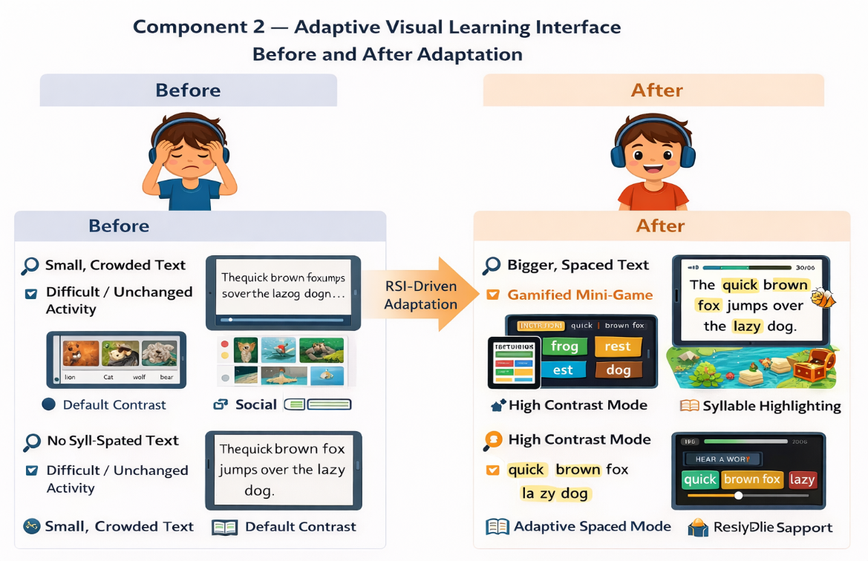
Figure 1:Before after gap showcase

1.3 Research Gap

1.3.1 What Is Missing
To start with, current systems that adjust the visual reading interface such as DAEL[1], RALF [3] and system suggested by Ilyas et al.[8] in which the visual learning parameters are taken into account, either once during the beginning of the session based on fixed learner profile or by manually defined rule-based triggers which influence just one visual dimension. No one of them uses a constantly changing strain signal as an input into a trained policy that chooses the most appropriate visual arrangement at each point of the lesson.
DAEL is not able to modify once established and is unable to update once the learning process has started [1][2]. RALF study only alters the font shapes, but leaves the visual parameters, e.g., spacing and contrast, untouched [3]. Similar to the system invented by Ilyas et al. involves rule based thresholds of restricted number of interface characteristics and does not include a learned decision policy [8]. Due to this, such systems adopt the presence of the learning disability label instead of adjusting to the dynamic mental state of the learner at the time of reading.
Second, studies on dyslexia typography have indicated that there is no standard visual presentation that is effective to all dyslexic students. Research by Wery and Diliberto [9] and Kuster et al. [10] established that specialized fonts of dyslexia failed to enhance reading faster than regular fonts. This data demonstrates that still visual environments cannot be considered enough. Rather, the evidence-based practice indicates that visual properties like spacing and contrast should be customized and changing according to the needs of a particular learner. Nonetheless, none of the available systems have a closed-loop policy to teach learners what visual layout creates less strain to a specific learner and dynamically adjusts the interface throughout the lesson.
Third, the typography research and adaptive reading systems available now have only been developed to work with Latin based scripts and a few of the cases were Arabic and Persian scripts. Nonetheless, Sinhalese and Tamil are abugida scripts, based on Brahmi, in which the sound of the vowels are signalled with diacritical marks, attached to or enwrapping consonant base characters in elaborate visual codes [11]. Lai et al. (2024) [12] states that this multi-part akshara enhances visual complexity of characters and may increase cognitive load of dyslexic readers. In spite of this, none of the current dyslexia interface systems concern visual parameter like diacritic offset or glyph padding, which are required to appropriately adjust visual structure of Sinhalese and Tamil text. Consequently, the use of visual adaptation techniques used in the Latin scripts can deteriorate the reading of those who are learning these languages.
Fourth, the systems like RALF [3] and Arunalu [13] have added gamification features, but they assume fixed or manually regulated activities. No exit system dynamically regulates the gamified learning activities as per the reading strain of the learner over the real-time. This implies that learners who have a higher cognitive load would still have the same level of difficulty as learners who are perfectly reading which will result in decrease of effectiveness of gamifications as a motivational tool.

1.3.2 Why Current Approaches Are Insufficient
The drawbacks of the existing methods are they do not consider all the facts at once. They put one into consideration at a time. Similar to a system that can reduce visual crowding but one that fails to set contrast may still fail to resolve the real issue the student is experiencing. Although both font and spacing can be adjusted, a system not able to change the difficulty of gamified activities can be problematic as well, when the learners are under high pressure.
Thus, to accommodate dyslexic students we must optimize together several visual parameters, such as font size, spacing, contrast and gamification challenge. This adaptation should be led by individual learner-state like Reading Strain Index (RSI), a closed loop learning policy that revised its decisions after observing the response of RSI was able to continuously change the interface to suit each learner.
It has been proven that digital learning tools to support dyslexic learners are viable and required in the local environment through the examples of Arunalu [13] and Pubudu [14] apps that are used to teach dyslexia in Sri Lanka. Nevertheless, these systems lack a reactive visualization of the reading interface. At the moment, a single system that integrates RSI-based visual adaptation, Sinhala/Tamil script-specific spacing intervention, and strain-based gamification control does not exist.

1.3.3 Novelty and Evidence-Based Justification
In this study, first RSI-based, closed-loop adaptive visual interface that will suit dyslexic readers of Sinhala and Tamil. The system makes font size, letter spacing, word spacing, contrast modes and gamification difficulty jointly maximized based on a learned policy that dynamically adjusts to the reading strain of the learner. As far as the reviewed literature knows, there is no existing system with such a combination of features.
The novelty of this component can be designed at four various levels such as parameter level, policy level, script level and population level.
On the parameter level, they did not have a jointly controlled system.
At policy level, there was no existing system that learned decision policy which maintains its behavior during reading session.
No dyslexia typography or interface platform deals with the problem of diacritic offset or glyph padding of Sinhala or Tamil abugida scripts, which would be required to fit the complex character systems properly [11][12].
Last but not least, on population level, no adaptive visual interface of dyslexic learners is designed and validated in Sinhala or Tamil medium learners in Sri Lanka [13][14][15].

Feature | DAEL [1] | RALF [3] | Ilyas et al. [8] | Arunalu [13] | Chutti Tamil App [16] | Tamil Vazhi Payirchi [17] | Avaz Reader [18] | This component
Real-time RSI-driven visual adaptation | No | No | No | No | No | No | Partial | Yes
Learned policy for visual parameter selection | No | Patial | No | No | No | No | No | Yes
Joint font + spacing + contrast control | Partial | No | Partial | No | No | No | Partial | Yes
Dynamic per-learner spacing optimization | No | No | No | No | No | No | No | Yes
Gamification difficulty adapted by strain | No | No | No | No | No | No | No | Yes
Sinhala/Tamil diacritic & glyph-level spacing | No | No | No | No | No | No | No | Yes
Validated for Sri Lankan learners | No | No | No | Partial | Partial | Partial | Partial | Yes
Within-session adaptation (not pre-session only) | No | No | Yes | No | No | No | No | Yes
Table 3:Confirmed Gaps

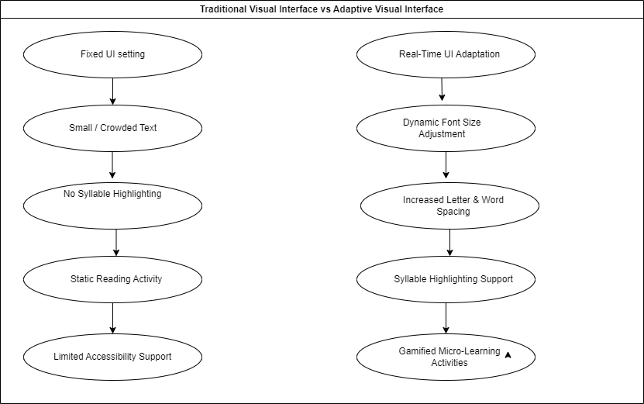
Figure 2:Traditional and Adaptive visuals

2. RESEARCH OBJECTIVES

2.1 Main Objective
The primary goal of the research is to design, implement and evaluate a real time closed loop adaptive Visual Learning Interfaces that personalize the typographic parameters, contrast settings, and gamification level to the dyslexic students. The system constantly changes depending on the Reading Strain Index (RSI) signal that indicates real time reading difficulty of the learner.
It is assumed that the system will lead to statistically significant increase in the within-session reading speed and a quantifiable decrease in the reading problems compared to the static interface. Besides this, the study presents the earliest dyslexia dedicated adaptive visual interface which can specifically support Sinhalese and Tamil abugida scripts filling a gap in the current dyslexia support framework.
To reach the abovementioned goal, the system dynamically adjusts the visual parameters, which are discussed on a real-time basis. These adaptations are motivated by RSI signal generated by the Cognitive Learning Signal Monitoring Engine as opposed to the use of manually or fixed themes. And the interface itself keeps on evolving depending on the strain of reading that a student is in. Second, the component adds script specific visual adaptation of Sinhalese and Tamil orthographies. Third, the interface combines strain-responsive gamified micro interventions, e.g., syllable-collect and decoding games. The system lowers the level of challenge to allow the learner to process information without cognitive overload when the strain is high. As the strain goes down, the system becomes harder to keep engaged and progress in learning slowly.
Lastly, the system captures reading performance measures e.g. reading rate and hesitation duration per learner and is able to use the results to determine the most effective visual configurations. In time, the process of adaptation policy learns to use those configurations, which enhance reading fluency in an individual learner.
2.1.1. Smart validation for main objective
Specific | Development of a closed-loop adaptive visual interface that modifies font size, spacing, contrast, and gamification difficulty for dyslexic learners using RSI signals, specifically supporting Sinhala and Tamil scripts.
Measurable | Achieve a statistically significant improvement in within-session reading speed, a measurable reduction in hesitation time,
Achievable | Implementation will utilize established reinforcement learning and contextual bandit algorithms, while consuming RSI signals through the Component 1 API.
Relevant | The work addresses four major research gaps: the absence of RSI-driven UI adaptation, the lack of learned visual adaptation policies, the absence of abugida script support, and the lack of strain-responsive gamification mechanisms.
Time– Bound | All phases of the system will be completed within the allocated academic year.
Table 4:SMART validation of main objective

2.1 Sub Objectives
- Implement the RSI-driven visual adaptation policy
The first one is to install reinforcement learning or contextual bandit policy to generate the best visual setting to present the reading interface. The RSI is obtained by the policy through component 01 (Design and implement the Multimodal Reading Strain Index (RSI) model of dyslexic reading sessions). In each of the sessions, choose one compound action that changes font size, letter spacing, word spacing and contrast ratio of the background. WCAG 2.1 dyslexia guidelines provide recommendations to be followed to make sure the system use will guarantee a successful learning session.
Success metric:
The system must have it that every session must cause at least one RSI-based visual adaption to enhance the RSI vector of the learner.

- Develop Sinhala and Tamil abugida script-specific visual templates
The second aim is to create Sinhalese and Tamil script-based visual templates. The parameters needed when developing such templates include parameters like diacritic-offset and glyph padding to avoid visual overlap of a consonant glyph and the diacritical mark on a vowel when dyslexia-adapted spacing is used.
The template should accommodate all font-size settings and space arrangements regarding the adaption policy. We will be able to guarantee appropriate visual representation among various interface states.
Success metric:
All Sinhalese and Tamil scripts should exhibit diacritic collision on all spacing settings. Visual inspiration will be used to ensure that the correct rendering is completed by two Sinhalese and Tamil literate reviewers.

- Evaluate the adaptive interface against a static baseline
Next objective is to evaluate the effectiveness of the proposed Adaptive Visual Learning Interface by comparing it with static visual interface configuration. The evaluation will be conducted using within-session A/B testing and a pilot study involving Sri Lankan dyslexic primary school students.
Performance will be assessed using two key metrics: reading speed (words per minute) and hesitation time per word. The study will also observe learner progression across reading curriculum levels over multiple sessions.
SuccessMetric:
The adaptive interface must demonstrate a statistically significant improvement (p < 0.05) in average reading speed compared to the static interface. Additionally, the system should show a measurable reduction in hesitation time and enable learners to progress through at least one curriculum level faster than in static interface sessions.

- Compare adaptive interface with a non-adaptive baseline.
The last goal will be to analyze the efficacy of the proposed Adaptive Visual Learning Interface with respect to the analysis of the static visual interface configuration. The assessment shall be performed by applying within-session A/B testing and a pilot study on Sri Lankan dyslexic primary school students.
Two important variables will be used to measure performance reading speed (words per minute) and the time per word hesitation. The research will also monitor the progression of the learners regarding reading curriculum levels in several sessions.
Success Metric:
The adaptive interface should prove statistically significant difference (p < 0.05) in the average reading speed with the adaptive interface, when compared with the non-adaptive interface. Also, the system is expected to demonstrate a quantitative decrease of the hesitation time, as well as allow learners to advance up to a minimum of one level of the curriculum framework quicker than in stationary interface classes.

3. METHODOLOGY
3.1 Research Approach - This paper suggests Design Science Research (DSR) in the creation and evaluation of Adaptive Visual Learning Interface (AVLI). DSR is appropriate because the main goal of this project is to create working software that solves a real-life problem and test it [19].
The research is conducted in three main phases:
- Problem identification and motivation
- Designing and building the AVLI
- Evaluating with real students
3.2 Data collection - two types of data are collected. The first is interaction data from 20 to 30 primary students (grade 3 – 5) which have Sri Lankan background. Each student has to complete a 20-minute reading session. In every 60 seconds, the system records click, scroll, reading speed, hesitation time, and the RSI value from Component 1. This data is used to train and refine the visual adaption policy.
The second type is visual ratings. For that choose 10 number of experts who can read both Sinhala and Tamil review 15 visual templates, five font size levels across three space options. Each is rated 1 to 5 for readability and comfortability. Any template which is poorly rated will be removed or recreated before its handover to the child.
3.3 Script specific rendering for Sinhala and Tamil - Sinhala and Tamil use an abugida writing system where vowel sounds appear as small marks attached to consonant letters. Standard CSS spacing tools were designed for left-to-right scripts like English. But when applied to Sinhala and Tamil, this causes some letters harder to identified by the dyslexic students.
To address this issue, there are two special parameters introduced which named as diacritic_offset, which repositions vowel marks, so they sit correctly without overlapping and glyph_padding, which adds space between complete character units rather than individual code points. These are applied using HarfBuzz for text sharping and rendering through a Flutter widget on the Android tablet. All 15 templates are reviewed by Sinhala and Tamil literate experts before use with children.
3.4 Visual adaption policy - The AVLI uses a contextual bandit algorithm called LINUCB to choose the best visual settings at each adaption step. Every 60 seconds, it receives an RSI value from Component 1. Based on this, LinUCB selects values for font size, letter spacing, word spacing, background contrast, animation speed, and game difficulty.
To achieve this, we take an experimental type of design in which we compare AVLI and a fixed point of the baseline. Set of the sessions using both adaptive and non-adaptive interfaces are administered to the same students. This will also assist in ensuring that the system is operated in the right direction but will also show measurable outcomes in the reading performance of the learners.
Before any student data is available, the system is pre-configured using WCAG 2.1 accessibility guidelines and starting point. The trained policy is exported as a TensorFlow Lite model and runs on-device within the Flutter application on the Android tablet. Visual changes are applied within 500 milliseconds of each RSI update.
We use clustering for new students. Clustering is applied to group students by visual response patterns. A new student is matched to the nearest existing group and given that group's starting visual preset, helping the policy converge faster.
3.5 Gamification Controller - when the student’s RSI goes high withing reading period, the system automatically replaces the current reading task with a short game such as syllable-collect activity or a word-matching game. The game difficulty is set two steps below the student’s last successful levels to keep the student motivated. When students come back to normal for three periods in a row then the difficulty level increases by one. This logic prevents rapid mode-switching.

3.6 A/B Testing – Each student takes part of six sessions, three with adaptive AVLI and another three with static visuals (WCAG 2.1 baseline). Session order is balanced across students. After each session, the system records RSI before and after. reading speed in words per minute, hesitation time per word, and the visual action chosen. All data is stored in a PostgreSQL database for offline analysis.

3.7 Ethics and Privacy - We believe in great ethical practices. The university approves ethics on the study. Students are given UUID. No names, photos, or school identifiers are stored. Raw sensor data from Component 1 (gaze, voice) is processed on the device and only the final RSI value is sent to the AVLI server. The high-strain threshold in the gamification controller provides a built-in safety safeguard, automatically reducing demand before strain reaches a harmful level.

3.8 Evaluation -
Technical Level: We measure the delay between the arrival of RSI and implementation of a visual change. The aim is below 500ms. We also have Sinhalese/Tamil rendering experts who confirm that it is correct before it can be used by pilots.
Within-Session Level: We compare the speed of reading and hesitation adaptive and static epochs with tests. We have reported statistical significance and effect size.
Medium-Term Level: Compared to adaptive and static status, we compare the extent of student progress in the curriculum over the six sessions. Success is the mobility of at least one more level among students using AVLI.
We also test the policy convergence through monitoring the changes of the session rewards over time. We hope to achieve a change in reward variance of at least 25% by session, which means that the policy is stabilized. Teachers and coordinators are interviewed by the test after which the interface and games are perfected.

4.HIGH-LEVEL SYSTEM ARCHITECTURE

4.1 Overview of the solution
The AVLI takes in a Reading Strain Index (RSI) value from Component 1 every 60 seconds. Based on this value, it picks the best combination of visual settings, font size, letter spacing, word spacing, background contrast, and game difficulty and sends these settings to the reading screen within a few milliseconds. The child never needs to do anything manually. All changes happen automatically in the background.

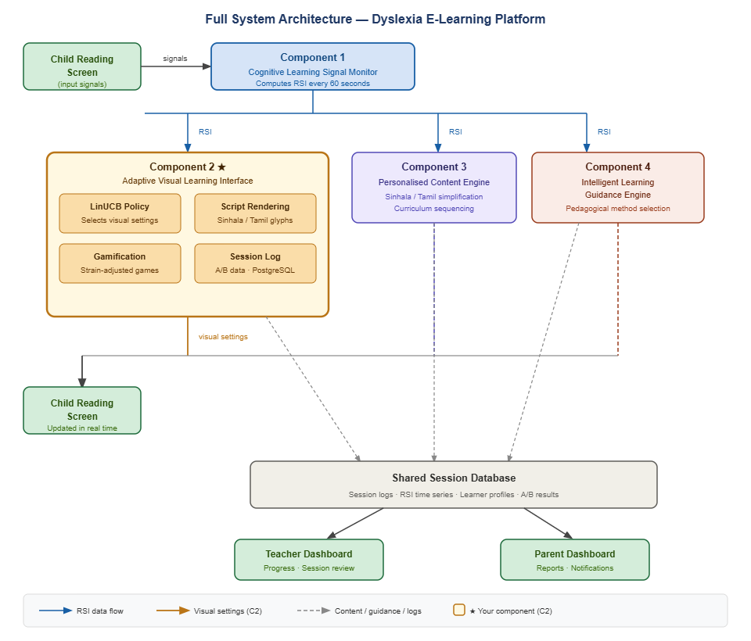
4.2 System diagram
Figure 3:System architecture

4.3 Highlight the individual component and its parts
As the first step taking the RSI from the component 01 and then it comes to an adaptive decision engine applies reinforcement learning techniques to choose the relevant visual modifications based on child’s current state. When learner loses interest or when learner faces any difficulty then the system integrates with gamified learning element which helps to reduce cognitive stress during the session.
Additionally, the interface cooperates with script specific adaption for Sinhala and Tamil to reduce the vowel sign placements and overlaps. These adjustments create a dyslexia friendly interface for the local community.
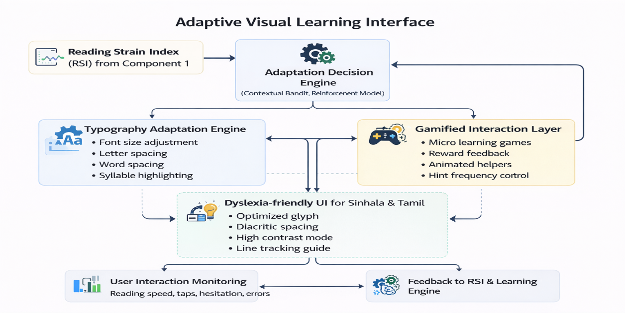

Figure 4:component architecture diagram

4.4 AVLI Internal Component
The AVLI has four internal parts that work together:
- LinUCB Policy - The brain of the system. It receives the RSI and decides which visual to apply. It learns over time.
- Gamification Controller - Monitors RSI. If the child is struggling for two periods in a row, it switches to a short game activity, so child feels less pressure. When the child recovers, it returns to normal reading.
- Script Rendering Layer - Handles Sinhala and Tamil text. It adjusts vowel mark positions (diacritic_offset) and spacing between character units (glyph_padding) so the text displays correctly.
- Session Log - Records every visual change made.

4.5 Component Interactions
Component | Direction | Data / Signal
Component 1 | Sends RSI to AVLI | RSI vector
Reading Frontend | AVLI sends to Frontend | Visual settings (font, spacing, contrast, game difficulty) via WebSocket
Session Database | AVLI writes to DB | Every visual action, RSI value, reading speed, and hesitation time logged in PostgreSQL
Component 3 & 4 | AVLI get the simplified content from component 3 | AVLI only handles visual interfaces. Get the simplified content from 3rd component and guidance handled by other components
Table 5:Component Interactions

4.6 Data Flow
Step 01 - Component 1 sends RSI value
Step 02 - LinUCB Policy reads RSI and selects a visual action
Step 03 - Frontend updates the screen (font size, spacing, contrast, or game activity)
Step 04 - System records outcome in session log
Step 05 - Policy weights are updated using the log data

4.7 Scalability and security considerations
01. Security –Data about student, voice data never leaves. Only the final RSI number is sent to the AVLI.
02. Privacy – Each student gets UUID. No name or details are saved.
04.Scalability - System can handle multiple students at the same time. The system requires a maximum of 4GB of RAM.
03. Portability – Native Flutter app on Android tablets

5. USER REQUIREMENTS

5.1 Stakeholder Identification
Stakeholder | Role | Interest in the AVLI
Dyslexic Students (Primary, Grades 3–5) | Primary end-users of the e-learning system | Require a visual reading environment that responds automatically to their real-time reading difficulty larger fonts, adjusted spacing, reduced contrast without needing to manually change any settings
Teachers / Special Education Staff | Monitor student progress; configure learning sessions | Require transparency in which visual configurations were applied during a session and whether gamified interventions were triggered, to interpret student progress reports accurately
Parents / Guardians | Consent providers; receive progress updates | Require assurance that their child's interaction data and biometric signals are anonymized and that the system does not expose raw gaze or audio data outside the device
School Administrators | Deploy and maintain the system on school hardware | Require that the AVLI runs on standard school-grade hardware without specialist infrastructure, and that it complies with school data protection policies
Platform Developers / System Integrators | Integrate the AVLI with Component 1 (RSI) and the reading frontend | Require clearly documented Flutter–backend API and Node.js REST endpoints, and reliable latency so that RSI updates are reflected in the visual interface within the defined response window
Research Team | Evaluate system performance; publish findings | Require structured session logs (visual actions, RSI values, reading speed, hesitation ms), exportable A/B comparison data, and reproducible pilot conditions
Table 6:Stakeholder Identification - Adaptive visual learning interface

5.2 Functional Requirements
The following functional requirements are specific to the Adaptive Visual Learning Interface (AVLI) component.

FR# | Requirement | Source
FR1 | The system gets Continuous RSI from signal monitoring engine at least every 60 seconds during each reading session. | SO1; RSI-driven visual adaptation policy
FR2 | Based on the received RSI vector, the system chooses the visual adaption that adjusts interface parameters like font size, spacing and animation speed. | MO1; joint visual parameter control requirement
FR3 | The system enforces safety constraints, ensuring that visual adaption to increase the learner’s RSI are not applied according to the LinUCB reward model. | SO1; RSI-driven visual adaptation policy child safety requirement and ethical constraint
FR4 | The system logs every visual adaptation including the visual action applied, the RSI value, the constraint status, and the estimated reward. | SO4; Compare adaptive interface with a non-adaptive baseline. A/B evaluation and session audit requirement
FR5 | The system sends visual configuration commands to flutter reading frontend reading interface through a Node.js backend configurations, allowing font, spacing, and contrast changes to be applied without reloading the page. | SO1; low-latency adaptation requirement; NFR1
FR6 | The system manages Sinhala and Tamil script rendering by applying glyph padding parameters appropriate to the current font size and spacing | SO2; Sinhala/Tamil script correctness requirement
FR7 | LinUCB policy supports warm-start initialization using WCAG 2.1 before any learner-specific session data is available. | SO1; the RSI-driven visual adaptation policy cold-start mitigation requirement
FR8 | The system provides an A/B mechanism assign learners between the adaptive (LinUCB policy active) and the static interface (WCAG 2.1 default configuration fixed) and logs all | SO3; Evaluate the adaptive interface against a static baseline,  within-subjects evaluation design requirement
FR9 | The system automatically triggers a gamified –concept and reduces game difficulty level when the RSI exceeds the high-strain threshold for two consecutive decision epochs. | SO3; Evaluate the adaptive interface against a static baseline, strain-responsive gamification requirement
Table 7:Functional Requirements

5.3 Non-Functional Requirements
NFR# | Category | Requirement
NFR1 | Performance | End-to-end latency from RSI receipt to visual configuration applied in the reading frontend
NFR2 | Reliability | System uptime during a single 20-minute reading session with no visual freeze
NFR3 | Security | All inter-component communication between the AVLI, Component 1 (RSI), and the reading frontend must be encrypted
NFR4 | Privacy | Raw data, audio recordings, and other biometric signals produced by Component 1 must not be transmitted to or stored on the AVLI server
NFR5 | Usability | Visual adaptation changes must not disrupt reading continuity, all passive visual adjustments must be applied without requiring any learner interaction or attention
NFR6 | Portability | The AVLI backend and frontend must deploy on standard school-grade hardware without specialist infrastructure
NFR7 | Maintainability | All AVLI REST and WebSocket API endpoints must be documented with an OpenAPI 3.0 specification accessible to Platform Developers (S5)
Table 8:Nonfunctional Requirements

6. COMMERCIALIZATION PLAN

6.1 User personas

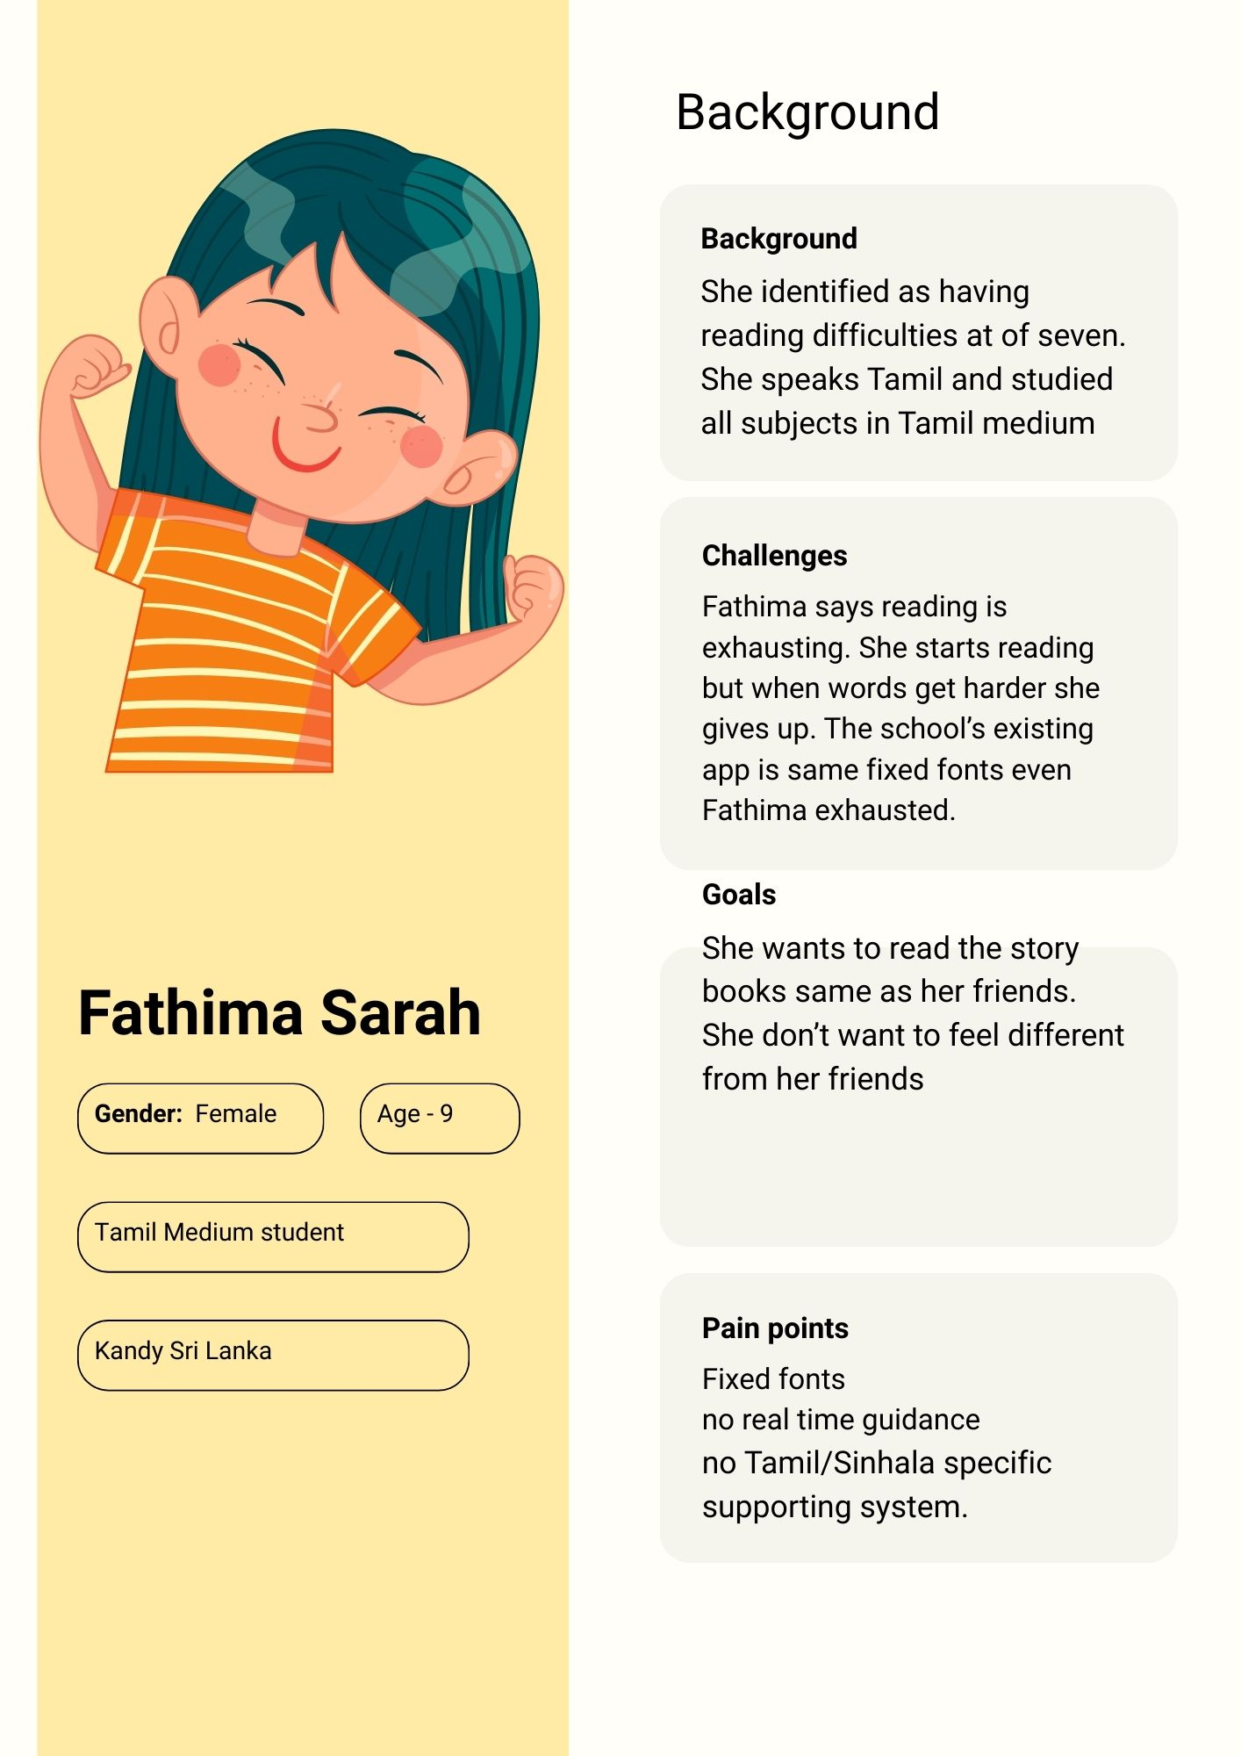  Figure 5:persona 1 | 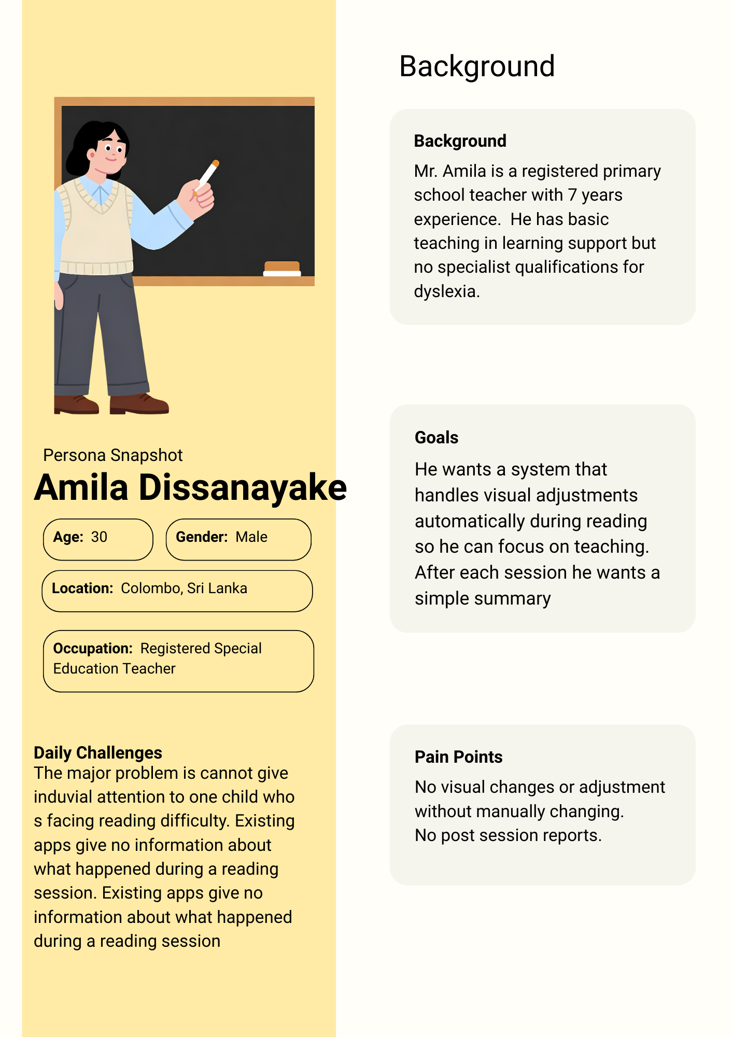  Figure 6:persona 2

6.2 Value Proposition
The proposed system provides a personalized mobile learning environment specifically designed for students with dyslexia. The platform combines adaptive learning techniques, personalized content selection, and dyslexia-friendly visual presentation to improve reading accessibility and engagement.
By analyzing learner interaction data, the system continuously adapts reading materials and learning activities according to the learner’s performance and reading ability. This approach allows students to practice reading at an appropriate difficulty level while gradually improving literacy skills.

6.3 Revenue Model
The system can adopt a subscription-based revenue model where schools or parents subscribe to the platform to access personalized learning features.
Possible revenue streams include:
- Individual user subscriptions for parents who want to support their children’s reading development at home.
- School licensing packages that allow multiple students to access the system within an educational institution.
- Premium educational content packages that provide additional literacy exercises and learning activities.
This model allows the platform to generate sustainable revenue while maintaining accessibility for educational users.

6.4 Cost Estimation
The main costs involved in developing and maintaining the system include:
System Development Costs
Costs related to mobile application development, system design, and implementation of adaptive learning functionalities.
Educational Content Development
Creation of Sinhala reading materials, literacy exercises, and curriculum-aligned educational content.
Cloud Infrastructure Costs
Expenses related to database storage, server hosting, and cloud services used to store learning data and system resources.
Maintenance and Updates
Ongoing system improvements, bug fixes, and updates required to maintain system performance and reliability.

6.4 Pricing Strategy
The pricing strategy is designed to ensure affordability for Sri Lankan schools and families.
Possible pricing plans include:
Plan Type | Target Users | Price Range | Features
Individual Student Plan | Individual students / parents | LKR 500 – LKR 700 per month | Access to personalized learning features and reading exercises
School Plan | Schools and educational institutions | LKR 25,000 – LKR 40,000 per year | Institutional access for multiple students and teachers
Free Basic Version | General users | Free | Limited reading exercises with basic learning features
Table 9:pricing strategy

6.5 Competitive Advantage
The proposed system offers several advantages compared to general digital learning applications:
- Focused support for dyslexic learners rather than general learning platforms.
- Personalized learning content selection based on learner performance.
- Adaptive visual reading interface designed to improve readability for students with dyslexia.
- Mobile-based learning accessibility, allowing students to practice reading anytime and anywhere.
- Content designed specifically for the Sri Lankan primary education context.
These features enable the platform to provide more targeted and effective reading support for students with dyslexia.

6.6 Intellectual Property Considerations
The proposed system includes several intellectual property elements that should be protected to support future commercialization.
Software Copyright
The mobile application, system architecture, and implemented algorithms will be protected under software copyright laws.
Educational Content Protection
All literacy exercises, reading passages, and learning materials developed for the system will be protected through copyright.
System Design and Algorithms
The adaptive learning mechanisms and content selection methods may be considered for intellectual property protection to prevent unauthorized use or duplication.
Proper intellectual property protection will help secure the innovation and support long-term commercialization opportunities.

7. BUDGET AND JUSTIFICATION
No. | Budget Item | Unit Cost (LKR) | Qty | Total (LKR) | Justification
Software Licenses
1 | Python 3.10 + scikit-learn + FastAPI + Redis | Free | — | — | All open-source zero cost. Core ML and API stack for Components 1, 3, and 4 classifiers, REST endpoints, and WebSocket server.
2 | Flutter SDK + HTML5 | Free | — | — | Open-source front-end stack for Component 2 adaptive UI and Component 4 intervention activities. No licensing fee.
3 | gTTS (Google Text-to-Speech) | Free | — | — | Free Python library. Supports Sinhala (si) and Tamil (ta) locales. Used in Component 4 for syllable audio and Template Song generation. Offline after first run.
4 | PostgreSQL — learner model and content database | Free | — | — | Open-source relational database. Stores BKT mastery, SM-2 schedules, intervention history, RSI logs, and content metadata across all components.
5 | GitHub Education Pack — version control and CI/CD | Free | — | — | Free for SLIIT students. Covers all four component repositories, Actions CI/CD pipelines, and private team collaboration.
6 | Figma — UI wireframes and usability prototypes | Free | — | — | Free student tier. Used for Component 2 visual template design and caregiver/teacher usability testing prototypes.
Cloud Services
7 | Oracle Cloud Free Tier — app hosting and PostgreSQL | Free | — | — | Always-Free tier provides 2 AMD VMs and 20 GB storage — sufficient for all four component microservices at research and pilot scale.
8 | Redis Cloud Free Tier — RSI event pub-sub streaming | Free | — | — | 30 MB free Redis instance sufficient for real-time RSI streaming between Component 1 and Components 2, 3, and 4 during pilot sessions.
9 | Internet charges — development and pilot study (6 months) | 400 | 6 | 2,400 | LKR 400/month Sri Lanka mobile data plan (~15 GB/month). Covers model downloads, package installs, gTTS API calls, and optional dashboard synchronisation.
Human Effort Costs
10 | Inclusive education specialist — exercise bank review | 3,000 | 1 | 3,000 | One-time review of Component 3 phonological drill bank and Component 4 multisensory activity design for clinical appropriateness and alignment with DSM-5 and ICD-11 dyslexia intervention principles.
11 | Song and poem authoring or copyright clearance | 2,000 | 1 | 2,000 | Commission culturally appropriate Sinhala and Tamil songs and rhymes for Component 4 Template Song activity, or obtain rights clearance. Content mapped to NIE phonological targets for Grade 1 and Grade 2.
12 | NIE curriculum material sourcing and digitization | 2,000 | 1 | 2,000 | Legal procurement, scanning, and digitization of Grade 1–3 Sinhala and Tamil NIE curriculum materials for Component 3 content mapping ontology and Component 4 word difficulty dataset construction.
13 | Ethics consent form printing (English, Sinhala, Tamil) | 30 | 160 | 4,800 | 160 pages: consent and participant information sheets for 20 pilot families across three languages, plus school administrator copies. LKR 30 per page standard Sri Lankan print-shop rate.
14 | Travel to partner schools — all field visits | 950 | 20 | 19,000 | LKR 950 per return visit (bus or tuk-tuk). Component 1 data collection: 6 visits. Component 2 usability testing: 4 visits. Component 4 pilot study, ethics submission, and close-out: 10 visits. Total: 20 visits across the project.
15 | Participant refreshments — pilot study sessions | 250 | 20 | 5,000 | LKR 250 per child per session for snacks and drinks. Ethical best practice for research involving children; builds rapport and reduces attrition across Component 1 and Component 4 sessions.
16 | Stationery, printed forms and field notebooks | 2,500 | 1 | 2,500 | Session observation checklists, researcher field notes, and annotation worksheets used across all four components during data collection and the pilot study.
17 | Contingency reserve (10% of direct cash costs) | — | — | 5,670 | Reserve for unexpected travel, reprinting, additional reviewer sessions, or minor unforeseen needs. Applied only to direct cash outgoings — not to zero-cost tools or free hosting services.
TOTAL ESTIMATED BUDGET (LKR) |  |  |  |  | 62,370
Table 10:budget calculation

8. WORK BREAKDOWN STRUCTURE (WBS)
ID | Task | Weeks | Effort %
Phase 1 - Research & Design (Weeks 1 - 4)
1.1 | Literature review and research gap analysis | W1–W3 | 10%
1.2 | Component design and system architecture | W2–W4 | 10%
1.3 | Ethics approval and consent form preparation | W3–W4 | 5%
Phase 2 - Build (Weeks 4 - 8)
2.1 | Sinhala/Tamil script rendering layer (diacritic_offset, glyph_padding) | W4–W6 | 15%
2.2 | Expert visual template review (15 templates) | W5–W6 | 5%
2.3 | LinUCB policy implementation with WCAG warm start | W5–W7 | 15%
2.4 | Gamification controller (syllable-collect, word-matching) | W6–W8 | 10%
2.5 | A/B testing infrastructure and session logging | W7–W8 | 10%
Phase 3 - Pilot Study (Weeks 8 - 11)
3.1 | Pilot study sessions with 20–30 students | W8–W11 | 10%
3.2 | Policy training and clustering | W9–W11 | 5%
Phase 4 - Evaluation & Report (Weeks 11 - 14)
4.1 | Statistical analysis and evaluation (reading speed, hesitation) | W11–W13 | 10%
4.2 | Final report writing and documentation | W12–W14 | 5%
Table 11:Work Break Down Structure

9. GANTT CHART
Phases | March | April |  |  | May |  |  | Jun | Jul | Aug | Sep | Oct | Nov | Dec
Proposal
Design Wireframes & Prototype
Data Collection
Backend Implementation
Data Processing
Model Development
Check List Submission
Progress Presentation 1
Final Check List Submission
Progress Presentation 2
Final Documentation
Website Submission
Final Presentation

Table 12:Grantt Chart

REFERENCES LIST
[1] A. Alsobhi, N. Khan, and H. Rahanu, "DAEL Framework: A New Adaptive E-Learning Framework for Students with Dyslexia," Procedia Comput. Sci., vol. 51, pp. 1947–1956, 2015, doi: 10.1016/j.procs.2015.05.452.
[2] W. G. Alghabban and R. J. Hendley, "An Empirical Approach to Validate the Dyslexia Adaptive E-Learning (DAEL) Framework," in Proc. IEEE Int. Conf. Adv. Learn. Technol. (ICALT), 2021, pp. 324–328.
[3] S. A. H. Minoofam, A. Bastanfard, and M. R. Keyvanpour, "RALF: An Adaptive Reinforcement Learning Framework for Teaching Dyslexic Students," Multimedia Tools Appl., vol. 81, no. 5, pp. 6947–6978, 2022, doi: 10.1007/s11042-021-11735-4.
[4] S. Weiler et al., "Reinforcement Learning in Education: A Systematic Literature Review," Int. J. Artif. Intell. Educ., 2025, doi: 10.1007/s40593-025-00494-6.
[5] S. Drigas and C. Mitsea, "AI for Students with Learning Disabilities," in Uses of Artificial Intelligence in STEM Education, Oxford Univ. Press, 2024, ch. 5.
[6] M. Franceschini et al., "Using Eye-Tracking to Assess Dyslexia in Children: A Systematic Review of Emerging Evidence," Educ. Sci., vol. 14, no. 11, Art. 1256, 2024, doi: 10.3390/educsci14111256.
[7] T. Nguyen et al., "Eye-Tracking in School-Age Specific Learning Disorders: A Practice-Oriented Narrative Review," Front. Educ., vol. 10, 2025, doi: 10.3389/feduc.2025.1759299.
[8] C. M. A. Ilyas et al., "Context Preservation Through Eye Tracking: Adaptive Reading Application Design," in Proc. ACM Symp. Eye Tracking Res. Appl. (ETRA), 2025, doi: 10.1145/3715669.3725897.
[9] J. J. Wery and J. A. Diliberto, "The Effect of a Specialized Dyslexia Font, OpenDyslexic, on Reading Rate and Accuracy," Ann. Dyslexia, vol. 67, no. 2, pp. 114–127, 2017, doi: 10.1007/s11881-016-0127-1.
[10] S. M. Kuster, M. van Weerdenburg, M. Gompel, and A. M. T. Bosman, "Dyslexie Font Does Not Benefit Reading in Children with or without Dyslexia," Ann. Dyslexia, vol. 68, no. 1, pp. 25–42, 2018, doi: 10.1007/s11881-017-0154-6.
[11] P. T. Daniels, "The Study of Writing Systems," in The World's Writing Systems, P. T. Daniels and W. Bright, Eds. New York: Oxford Univ. Press, 1996, pp. 1–17.
[12] J. Lai, J. F. Quinonez-Beltran, and R. M. Joshi, "A Bigger Picture of Early Literacy and Biliteracy Acquisition in Abugidas," Read. Res. Q., vol. 59, pp. 499–513, 2024, doi: 10.1002/rrq.555.
[13] L. Sandathara, S. Tissera, R. Sathsarani, H. Hapuarachchi, and S. Thelijjagoda, "Arunalu: Learning Ecosystem to Overcome Sinhala Reading Weakness due to Dyslexia," in Proc. 2nd Int. Conf. Advancements Comput. (ICAC), 2020, pp. 416–421, doi: 10.1109/ICAC49085.2020.9357268.
[14] R. Kariyawasam et al., "Pubudu: Deep Learning Based Screening and Intervention of Dyslexia, Dysgraphia and Dyscalculia," in Proc. IEEE 14th Int. Conf. Ind. Inf. Syst. (ICIIS), 2019, pp. 476–481, doi: 10.1109/ICIIS47346.2019.9063301.
[15] S. Thelijjagoda et al., "Interactive Digital Sinhala Reading Tools for Early Dyslexia Detection," in Proc. Int. Conf. Advancements Comput. (ICAC), Sri Lanka, 2021.
[16] Eduplay India, "Chutti Tamil Arichubadi — Tamil Script Learning Application," Google Play Store, 2016. [Online]. Available: https://play.google.com/store/apps/details?id=com.eduplay.chutti
[17] IIT Madras and Madras Dyslexia Association, "Tamil Vazhi Payirchi: Screening and Remediation Package for Tamil-Medium Dyslexic Students," Chennai, India, 2022.
[18] Avaz Inc., "Avaz Reader: Visual Reading Aid with Customisable Fonts and Colours," Avaz Inc., 2023. [Online]. Available: https://www.avazapp.com
[19] A. R. Hevner, S. T. March, J. Park, and S. Ram, “Design science in information systems research,” MIS Quarterly, vol. 28, no. 1, pp. 75–105, Mar. 2004.

11. APPENDICES

11.1 Risk analysis
Risk | Impact | Action
RSI from component 1 comes late or not at all and stopping the AVLI from making visual changes | High | If no RSI arrives within 90 seconds, keep all settings and logs.
Sinhala or Tamil vowel marks may still overlap characters after applying diacritic_offset and glyph_padding | High | Have two Sinhala/Tamil-literate reviewers check all 15 visual templates before any child uses the system
School devices may be too slow to apply visual changes within quick time basis | Medium | Test on the lowest-spec school device available, optimize the TensorFlow Lite model size for fast on-device inference
Student may find the gamified micro-tasks too easy or too boring if difficulty is too slow | Medium | 2 high epochs to trigger, 3 low epochs to return (according to RSI change the complexity)
Start the script rendering work in the first sprint; build a simple version first, then refine | Medium | Pre-load WCAG 2.1 dyslexia defaults as starting weights so the system makes safe choices from session one
Table 13:Risk Analysis

11.2 plagiarism report
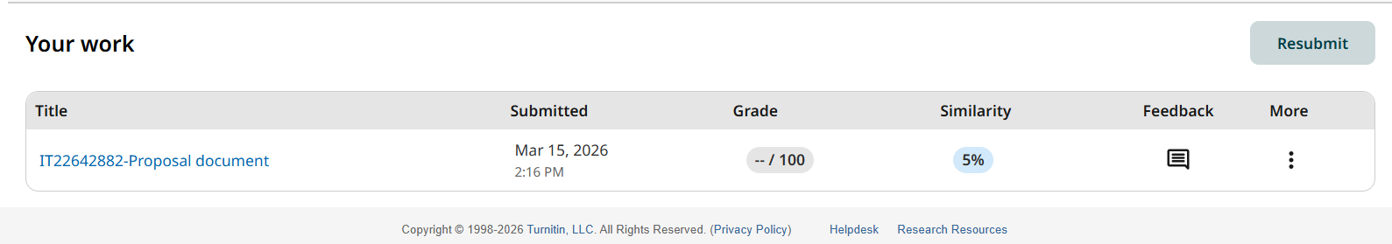
Figure 7:Turnitin report

